**A COMPREHENSIVE ANALYSIS OF FINANCIAL PERFORMANCE: INSIGHTS FROM A LEADING BANKS**

Project Based Experiential Learning Program

**INDEX**

|  |  |  |
| --- | --- | --- |
| S. NO. | CONTENTS | PAGE NO. |
| 1. | Introduction   * 1. Overview   2. Purpose | 02 |
| 2. | Problem definition and Design thinking  2.1 Empathy map  2.2 Ideation and Brainstorming map | 03&04 |
| 3. | Result  3.1 Worksheets, dashboard and story  3.2 Database Connectivity | 05 – 08 |
| 4. | Advantages and disadvantages of the project | 08&09 |
| 5. | Applications | 10 |
| 6. | Conclusion | 10 |
| 7. | Future scope | 11 |
| 8. | Appendix | 11 |

1.Introduction:

1.1 Overview

A comprehensive analysis of financial performance insights from a leading bank would typically involve a detailed examination of the bank’s financial statements, along with an evaluation of key financial ratios and performance indicators. The goal of such an analysis is to assess the bank’s overall financial health and to identify any areas of strength or weakness.

1.2Purpose

By analyzing financial performance, one can identify the areas where the bank is performing well and the areas where it is struggling. This can help the bank’s management team to focus on areas that need improvement and make strategic decisions accordingly.

The financial performance can help assess the bank’s overall financial stability. This can be useful for investors, regulators, and other stake holders who need to understand the bank’s financial health.

2.Problem definition and design thinking:

2.1 Empathy map

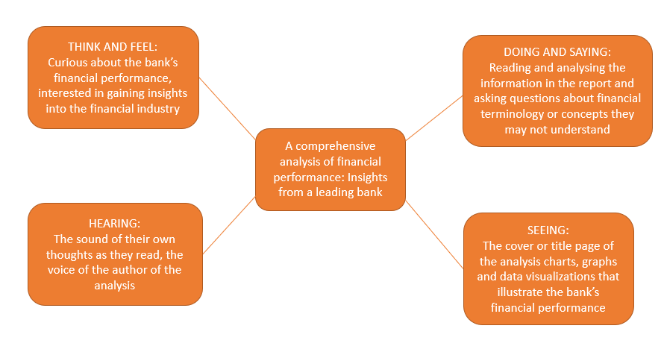

2.2 Ideation and Brainstorming map

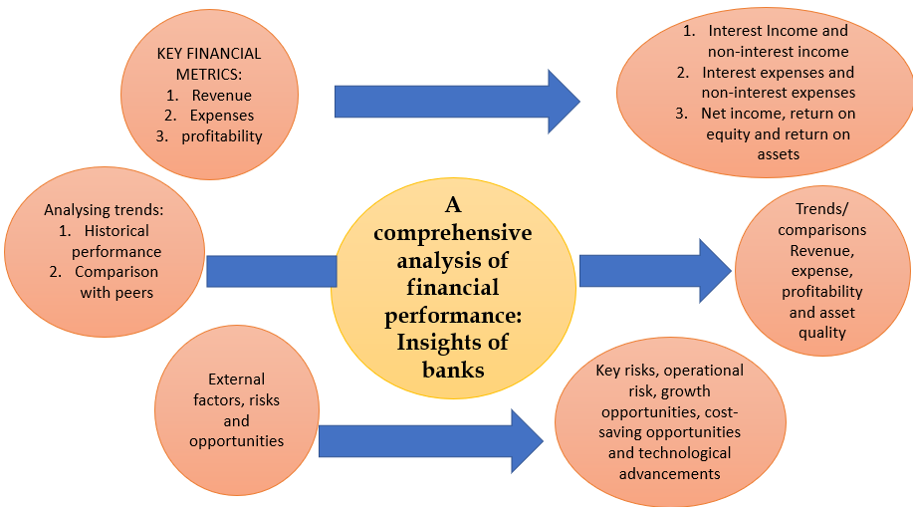

3.Result:













Dashboard:

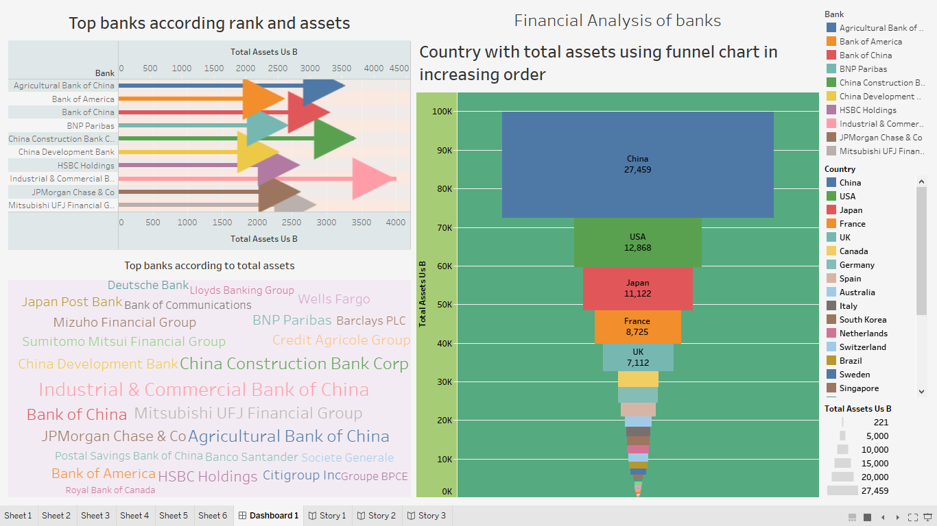

4.Advantages and Disadvantages of the Project:

4.1 Advantages

* **Identifying strengths and weaknesses**: A comprehensive analysis of financial performance insights can help identify a bank's strengths and weaknesses. This can allow the bank to capitalize on its strengths and address any areas of weakness to improve its financial performance.
* **Making informed decisions**: A detailed analysis of a bank's financial performance can help executives make informed decisions about future investments, risk management strategies, and resource allocation.
* **Improving profitability**: By identifying inefficiencies and opportunities for improvement, a comprehensive analysis can help a bank increase its profitability.
* **Enhancing investor confidence**: A thorough analysis of financial performance can provide investors with a clearer understanding of a bank's financial health, which can increase their confidence in the bank and attract more investment.

**4.2 Disadvantages**

* **Complexity:** Financial performance analysis can be a complex process that involves analyzing large amounts of data, making it time-consuming and difficult for individuals who are not well-versed in financial analysis to understand the insights.
* **Data Availability**: Depending on the bank, there may be limitations on the data that is available for analysis. For example, some banks may not disclose certain financial information, or the information may be difficult to obtain due to privacy concerns or data protection regulations.
* **Reliance on Historical Data**: Financial performance analysis is often based on historical data, which may not accurately reflect future performance or changes in the market.

**5.Applications:**

* **Investors**: Investors can use financial performance insights to assess the bank's profitability, growth potential, risk profile, and overall financial health. This information can help them make informed investment decisions and evaluate the bank's ability to generate returns and pay dividends.
* **Analysts**: Financial analysts can use financial performance insights to provide insights and recommendations to investors, as well as to evaluate the bank's position within the industry. They can also use this information to identify trends, forecast future performance, and compare the bank's performance to that of its peers.
* **Regulators:** Regulators can use financial performance insights to monitor the bank's compliance with regulatory requirements, assess its risk profile, and identify potential issues that may require further investigation or intervention.
* **Management team**: The bank's management team can use financial performance insights to assess its performance relative to its objectives, identify areas of strength and weakness, and make informed decisions about resource allocation, strategic direction, and risk management.

**6.Conclusion:**

Assessing the company's financial health, evaluating investment opportunities, or determining the financial feasibility of a project. It should also highlight any significant trends or issues that were identified during the analysis.

**7.Future Scope:**

* **Revenue streams**: An analysis of a bank's revenue streams can provide valuable insights into its financial performance. This could include an examination of the bank's interest income, fee income, trading revenue, and other sources of revenue.
* **Risk management**: Banks are exposed to a wide range of risks, including credit risk, market risk, and operational risk. An analysis of a bank's risk management practices can provide insights into its overall financial health.

**8.Appendix:**

<https://public.tableau.com/views/A_COMPREHENSIVE_ANALYSIS_OF_FINANCIAL_PERFORMANCE_INSIGHTS_FROM_A_LEADING_BANKS/Story2?:language=en-US&:display_count=n&:origin=viz_share_link>

<http://financialanalysis.nicepage.io/?version=334a6010-9823-4fa2-993e-d14cb7c9758e>

<https://github.com/sneha3050/The-comprehensive-analysis-of-financial-performance_Insight-from-leading-banks.git>

------